Home learning – Weeks commencing 18th & 25th of January 2021
Our learning focuses this fortnight are Winter/Ice and Robert Burns Day.
This Photo by Unknown Author is licensed under CC BY
This Photo by Unknown Author is licensed under CC BY

Literacy | Numeracy | Health and well being | Other context for learning
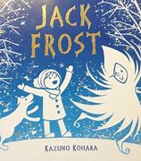Listen to the story Jack Frost you can find it here -https://youtu.be/igsDNgU0ed4  Questions you may wish to ask –  What animals hibernate? (You may wish to extend this and do some additional research on hibernating animals).  When have you noticed signs of Jack Frost and where? What does it feel like? How do you feel? How can you keep warm?  Jack Frost did not like warm things as he would melt. What things are warm?  What happens in Springtime?  Did you like/dislike this story and why?  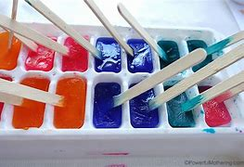 Ice cube mark making. (Using tubs/ice cube tray etc if you do not have lollipop sticks use sticks/spoons etc adding a little food colouring or paint.) Share and tell us about it on our Facebook page.  Write your name/make marks in ice (or snow). What did you use to write it? What letters are in your name? What other words start with that sound?  If no snow or ice you can improvise and mark make using shaving foam or flour.  https://youtu.be/Ckhyx9QCMpo  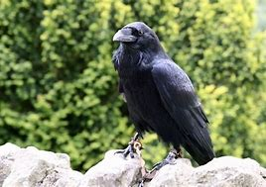 Learn a Scottish song ‘3 Craws ‘is one of my favourites. Can you learn another Scottish song or poem?  Share to your group page – may even be a prize or two!  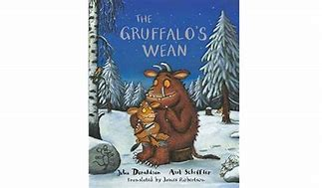  https://youtu.be/pOvNw-SzM0c  The Gruffalo’s wean a Scottish version of one of our favourites the Gruffalo’s child. Discussing the snowy winter scene, the animals, and the words. What new words have you heard? What does that word mean? | 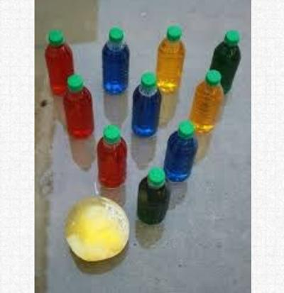  Make and use an ice balloon – see below (or ball) play some bowling. Write numbers on the bottles – What bottles were knocked down? What numbers are left standing? How many fell? How many still to knock down?  These experiences will support number recognition, number sequencing when placing the bottles, counting skills, observing more or less once knocked down.  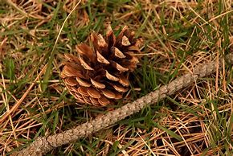  Following your scavenger hunt – (Poster below) bring your items home.  What item do you have more of each? How many do you have? How many more do we need to have them the same? How many altogether?  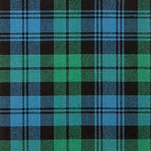  Using a ruler/straight edge. What is a pattern? Can you create a pattern? What colours are in your pattern?  Does your family have a family tartan – share an image. | 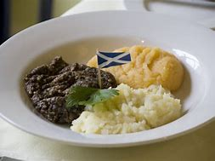  If you as a family will be having haggis, neeps, and tatties. Help prepare your burns dinner. Did you like the meal? Are any of the foods a new food of trying?  OR  Help make some yummy short bread. https://www.bbc.co.uk/food/recipes/shortbread_1290  Remember to show off your great hand washing techniques. 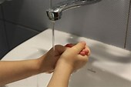  Enjoy family time and having time outdoors is important. Go on bikes and scooters etc.  Wrap up warm –  https://youtu.be/73qom9IueV8 the coat trick if you need help putting your coat on.  Once you can do this have a go at doing your buttons or zips. It can be tricky but keep trying.  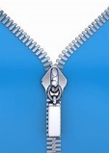  Go on a Winter scavenger hunt.  (Poster below)  Observe different environments Do you notice different things? How does it feel?  Is it colder/darker?  How do you feel? | Ice exploring  What is ice? How is ice made? What animals like ice/cold weather conditions? How can we melt ice?  https://www.edinburghzoo.org.uk/webcams/penguin-cam/?camID=2458  Live penguin camera at Edinburgh zoo.  Some ice experiences –  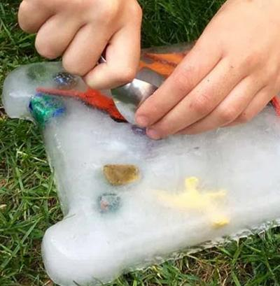 Oh no! Some of your toys have been trapped in ice – How will you free them? What will melt the ice? (chisel them out with spoons, salt, warm water, sun shine). How did you free yours? Did you try more than one way and what was the quickest?  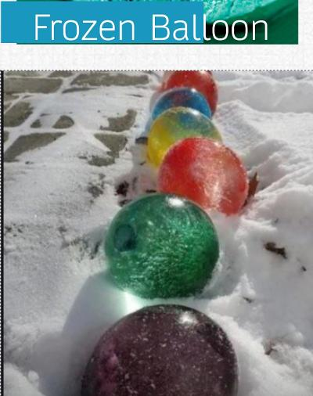 Freeze some balloons you may wish to add some food colouring. If you don’t have balloons don’t worry just use some empty tubs etc. Put them in different places – one in your freezer, hide them around the garden up high and low, in hedges, sheds etc.  Do some places freeze quicker than others?  Why do you think it didn’t freeze this time if the weather is a bit milder?  Why do you think some places may take longer?  Once frozen remove from balloon or tub.  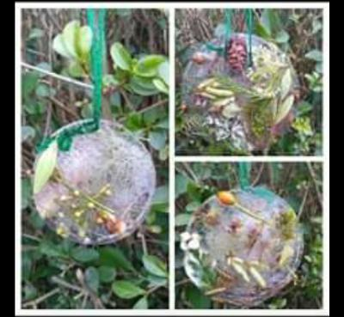  Collect some natural items on your walk and create some beautiful ice ornaments.  Put them in a bowl and freeze – remember to add some ribbon/string etc if you have some and hang them outside. We look forward to seeing what you found on your walks and sharing your pictures of your creations.
