Communication | Pre- Maths | Health and Well-being
Watch the story of the gingerbread man  The Gingerbread Man | Fairy Tales | Gigglebox - YouTube  When you have watched it you may like to make your own gingerbread men?  Or you could make some lovely playdough with some gingerbread flavoring – it smells lovely!  https://www.sweetsugarbelle.com/2011/12/gingerbread-playdough/  Do you have any animals from the story – can you find them around the house? Can you name them and tell your family what noises they make? Are they big or small and where do they live? | 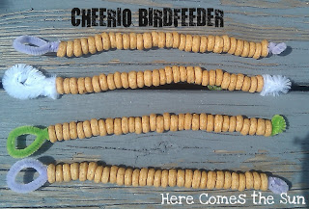  Create some cheerio bird feeders to hang in your garden/ near your home.  Cut the string different lengths – count ten cheerios to fill your feeders.  See if you can pop them on all by yourself.  Hang them outside and watch what visitors come for lunch!  Bake some lovely fairy cakes and count how spoons or cups you need to make them – add your own decorations and send us a picture of you making them and then eating them!!  Watch counting to ten video with penguins!  https://www.youtube.com/watch?v=Yt8GFgxlITs | 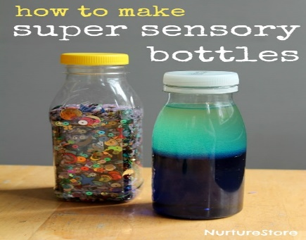  Make your very own sensory bottles like we have at nursery – pop on some relaxing music and have some quiet time when they are completed.  https://www.teachinglittles.com/how-to-make-simple-diy-glitter-sensory-bottles/  Get all wrapped up and go for a lovely walk with your family – what did you do and what did you see? We like to visit the ducks when we go on a walk from nursery, is this where you went? Send us some pictures of you out and about.  Did you play at the park? – show us some pictures of you out in your bikes or scooters. We you outside running or jumping in puddles – perhaps you were and throwing and catching a ball?

